CLEANHOME : CONVENIENT SERVICE

Boyi Zhang#1, Henry Wong#1

*# Seidenberg School of Computer Science and Technology, Pace University  
1 Pace Plaza, New York, NY 10038, USA*

1bz21819p@pace.edu

2hwong@pace.edu

***Abstract*— This article introduces CleanHome - a convenient service platform. There are many service needs in the current market, but due to the inherent problems of traditional housekeeping services, such as difficulty in making appointments and quality assurance, it is difficult for users to obtain a satisfactory service experience. To solve this problem, we have developed a convenient service platform, which provides one-stop housekeeping services through mobile applications and websites, including household cleaning, machine repair, gardening and other services. Users can easily book and pay for services through the platform. And this platform also provides multiple service providers that allow users to compare and choose. The platform also provides a path for users to give feedback, and Cleanhome will continue to improve to provide users with better services.**

***Keywords***— **convenient service platform, one-stop, easily book and pay, multiple service providers, feedback.**

1. **INTRODUCTION**

As the pressure of urban life continues to increase, more and more people need domestic services to reduce the burden of daily life. However, there are many problems in traditional housekeeping services, such as opaque services, difficulty in making appointments, and difficulty in guaranteeing service quality. In recent years, with the popularization of the Internet and mobile technology, housekeeping services based on network platforms have begun to rise, becoming a new choice for people looking for convenient and efficient housekeeping services.

This paper proposes a web-based convenient service platform, aiming to provide users with more efficient, transparent and professional housekeeping services. This platform uses mobile applications and websites as carriers to provide one-stop housekeeping services, including household cleaning, electrical repair, gardening and other services. Users can easily book and pay for services through the platform, and we also provide professional housekeeping service guarantee and after-sales service. Moreover, the CleanHome platform promises that users can easily cancel or modify orders without charging any fees.

1. **LITERATURE REVIEW**

This section provides four similar apps and analyzes their main functions and modes.

1. Urban Company

Urban Company is a web-based housekeeping service platform. This platform provides on -site housekeeping services. The main service provided is the cleaning of the room. And they are charged for hours, and some areas need to be charged separately, such as cabinets and bathrooms. This platform provides two service modes, one is regular cleaning, and the other is the move in/out cleaning. Except for cleaning, the platform does not provide other services.

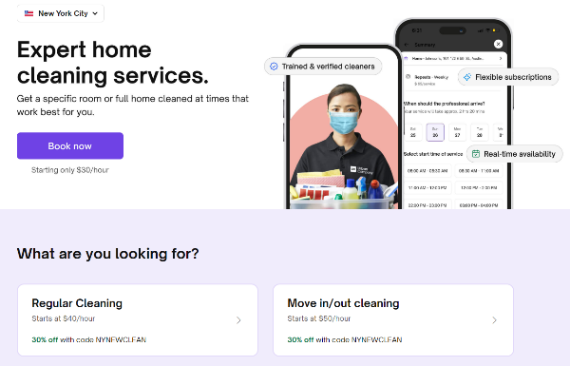

1. Cleany NYC

Cleany Nyc is a web -based housekeeping service platform. Its main target customers are people living in New York. It is very detailed in the division of service types. It includes Commercial & Office Cleaning Service, upholsted & Furnitive Cleaning, Disinfecting Service, etc. The main interface of this platform is a brief introduction to this platform. If the user wants to make an appointment for the housekeeping service, the user needs to jump multiple pages to find the appointment interface.

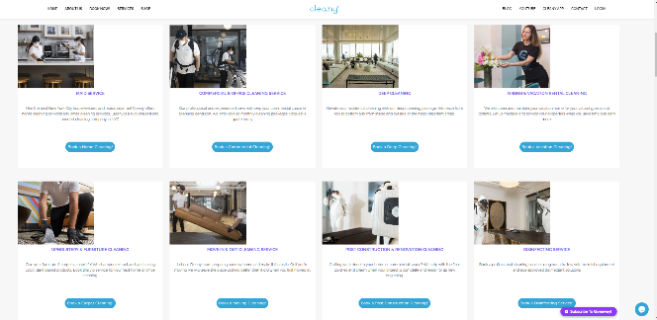

1. Spruce: Cleaning & Chores

Spruce: Cleaning & Chores is a mobile app. Its main service is housekeeping and chores. It has only three main interface Book Service, My Booking and Profile. This makes the APP look very concise and convenient for users. It has a very convenient time choice function and segmented the cleaning area. Users can choose to clean according to their needs, and they will not worry about waste.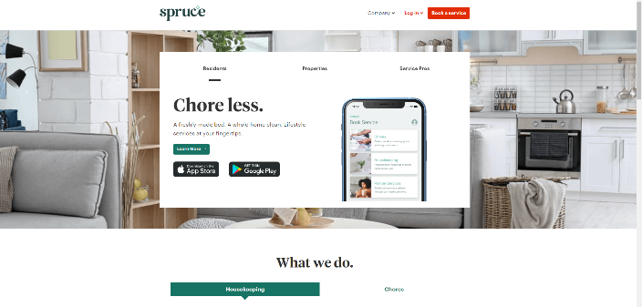

1. Care.com

The Care.com APP has a mobile version and web version. Its service is very comprehensive. There are Child Care, Senior Care, PET CARE, Housekeeping, Special Needs and Tutoring. Its main function is housekeeping services and care for children and pets. And it shows the detailed information of the service provider in the APP. This solves the problem of trust in the field of housekeeping services. Users can make service booking based on the information of these service providers.

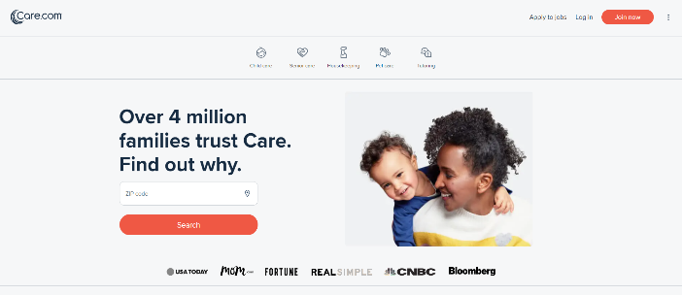

1. **EVALUATION AND ANALYSIS**
2. In comparison to traditional housekeeping services, CleanHome offers several key advantages. The platform's one-stop shop approach provides users with a convenient and efficient way to book a wide range of services, while also offering the ability to compare and choose between multiple service providers. The platform's easy-to-use interface and streamlined booking and payment process also set it apart from traditional housekeeping services.
3. In comparison to other network-based housekeeping platforms, CleanHome's emphasis on user feedback and continual improvement sets it apart. Our platform provides a dedicated feedback channel for users to share their experiences and suggestions, which allows us to continually improve the quality of our services.
4. In the future, we plan to integrate more services, such as pet care and personal shopping, and expand our service coverage to more geographical areas. We also plan to automate and optimize the reservation and payment process to provide a more streamlined user experience.
5. **PROJECT REQUIREMENTS**
6. Introduction

The aim of this project is to develop a web-based application that provides users with a convenient and efficient way of booking and paying for housekeeping services. The web app will be designed to meet the needs of modern urban life by offering a one-stop solution for all housekeeping needs of users. The project requirements are as follows:

1. Functionality

The web application should provide the following functionality:

1. Services Provided

The application should provide a wide range of housekeeping services, including household cleaning, electrical repair, gardening, and other services.

2. Booking and Payment

The application should allow users to easily book and pay for services through the website. Users should be able to select the service they need, choose a service provider, and confirm the booking. Payments should be made online through various payment options, including credit/debit cards, e-wallets, and other electronic payment methods.

3. Multiple Service Providers

The application should provide multiple service providers, allowing users to compare and choose the service provider that best suits their needs. This should ensure that users get quality services at competitive prices.

4. Feedback and Reviews

The application should provide a path for users to give feedback on the services received, which will help the platform to improve and provide better services to the users. Users should also be able to read reviews and ratings of service providers before making a booking.

5. Service Guarantee and After-sales Service

The application should promise to provide professional housekeeping service guarantees and after-sales services. If users are not satisfied with the services received, they should be able to contact the platform for a refund or a re-service.

1. Design and User Experience

The web application should be designed to provide a seamless and user-friendly experience. The application should be intuitive, easy to navigate, and aesthetically pleasing. The design should be optimized for desktop and mobile devices and should be responsive to different screen sizes.

1. Technical Requirements

The web application should meet the following technical requirements:

1. Browser Compatibility

The application should be compatible with all major web browsers, including Chrome, Firefox, Safari, and Edge.

2. Security

The application should use secure and encrypted connections for all data transfers and should comply with industry-standard security protocols.

3. Performance

The application should be optimized for fast and responsive performance, even in low-bandwidth environments.

4. Scalability

The application should be designed to handle a large number of users and service providers without compromising performance or stability.

1. Conclusion

In conclusion, the project requirements are aimed at developing a web-based application that provides a convenient and efficient way for users to book and pay for housekeeping services. The web app should provide a one-stop solution for all housekeeping needs of users, with a focus on quality, convenience, and user experience. The application should be compatible with all major web browsers and should meet industry-standard security protocols and performance requirements.

1. **SYSTEM DIAGRAM**
2. Conceptual Diagram

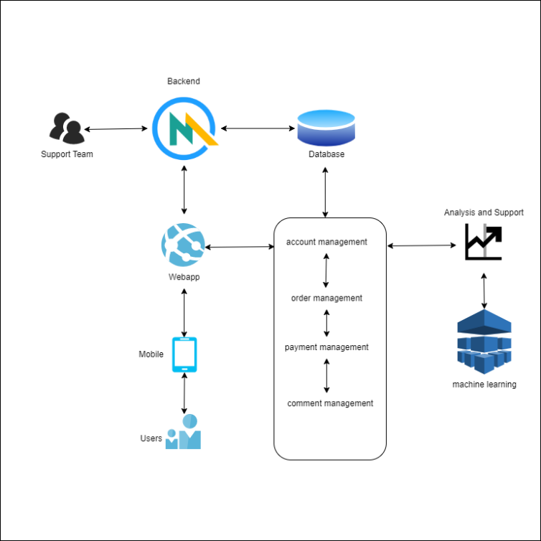

*Figure 4.1 Conceptual Diagram*

Figure 4.1 shows Conceptual Diagram. The arrangement and relationship of key factors in this Diagram system. Users access to applications, user personal information, order information, feedback will be stored in the database. Support Team can view and change the information through the back end. And the research will use machine learning to analyze the user's behavior habits based on databases.

1. Sequence Diagram

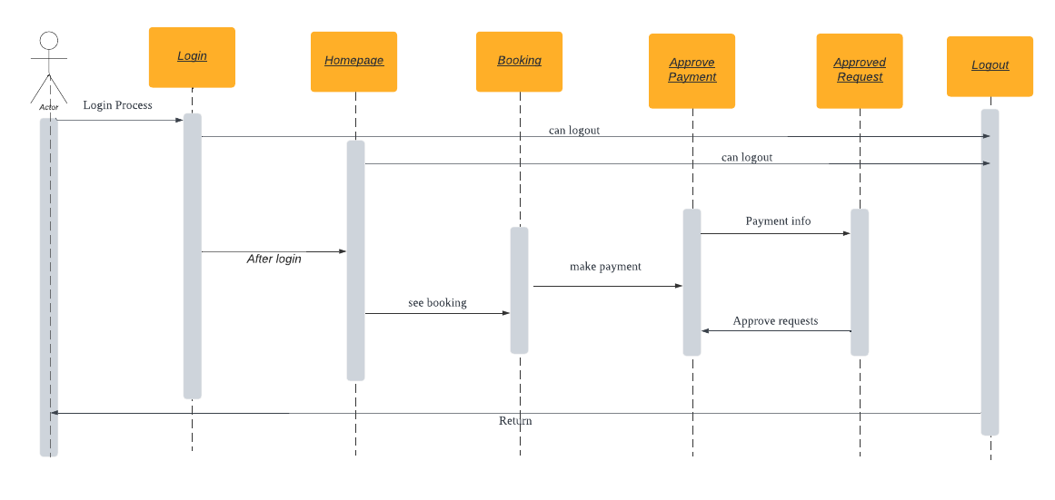

*Figure 4.2 Sequence Diagram*

Figure 4.2 shows Sequence Diagram. Sequence diagram shows object interactions arranged in time sequences. The user enters home page through Login. Booking at home page. Then pay the bill. At last, system generate orders. The user returns the login interface after logout.

1. Class Diagram

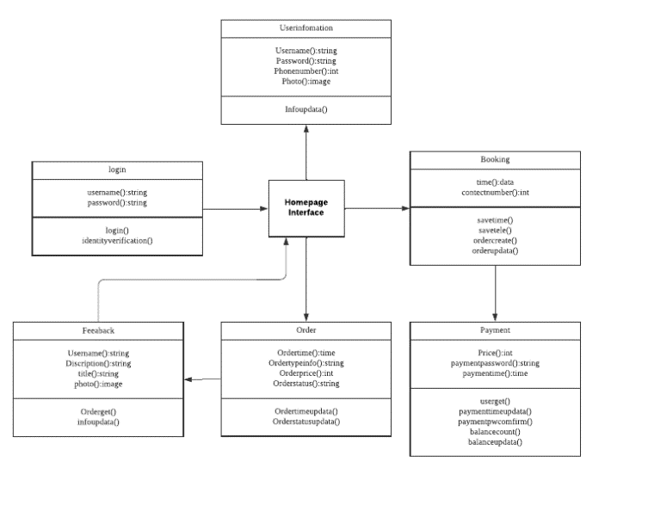

*Figure 4.3 Class Diagram*

Figure 4.3 Show Class Diagram. Class diagram is a static structure diagram. It shows the structure, attributes and operation of the Cleanhome system.

User information Class: User information Class includes attributes such as user ID, user name, password, contact phone number.

Service class: Service class represents the services provided by the Cleanhome platform. Service Class includes attributes such as service ID, service name, service description, service price.

Login Class: Login Class represents the login system of the Cleanhome platform. Login class includes username and password.

Booking Class: Booking Class means that the user's service order on the Cleanhome platform. Booking class includes the scheduled time, contact phone number and other attributes.

Order Class: Order Class represents the user's order information on the Cleanhome platform. Order Class includes attributes such as order ID, service type, service provider, service price, service time and other attributes. The order category also includes methods related to order status.

Payment class: Payment class means that users pay service fees on the Cleanhome platform. Payment classes include payment ID, payment method, payment time and other attributes.

Feedback Class: Feedback Class represents the user's feedback on the service experience. Feedback class includes feedback ID, feedback content, feedback time and other attributes.

1. Use case Diagram

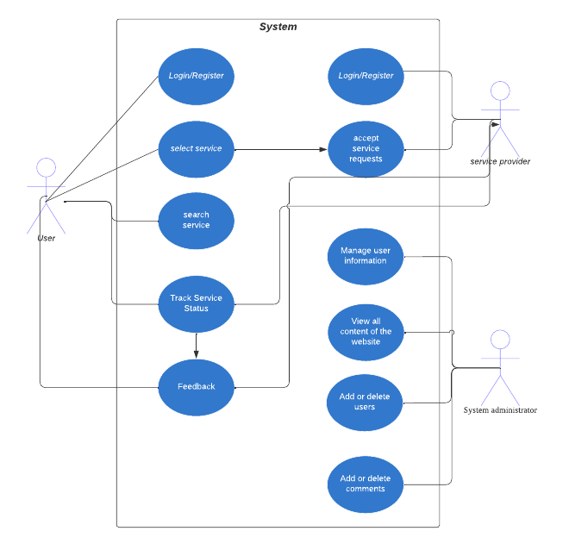

*Figure 4.4 Use case Diagram*

Figure 4.4 shows Use case Diagram. The Use case Diagram shows the relationship between users, service providers, system administrators and use cases related to Cleanhome.

// The remaining content will be completed in CS692